Ex. No : 10
DEVELOP AN APPLICATION THAT CREATES AN ALERT
UPON RECEIVING A MESSAGE
Date:

AIM:
To develop an android application that creates notification alert upon receiving a message using android studio and sdk.

PROCEDURE:

Step 1 : File → NewProject
Provide the application name and Click “Next”

Step 2 : Select the target android devices
Select the minimum SDK to run the application. Click “Next”.

Step 3 : Choose the activity for the application (By default choose “Blank Activity). Click
“Next”.

Step 4 : Enter activity name and click "Finish".

Step 5 : Edit the program.

Step 6 : Run the application, 2-ways to run the application.
1. Running through emulator
2. Running through mobile device

SOURCE CODE:-

AndroidManifest.xml
<?xml version="1.0" encoding="utf-8"?>
<manifest xmlns:android="http://schemas.android.com/apk/res/android"
package="com.example.administrator.ex10alert" >
<application
android:allowBackup="true"
android:icon="@mipmap/ic_launcher"
android:label="@string/app_name"
android:theme="@style/AppTheme" >
<activity
android:name=".MainActivity"
android:label="@string/app_name" >
<intent-filter>
<action android:name="android.intent.action.MAIN" />
<category android:name="android.intent.category.LAUNCHER" />
</intent-filter>
</activity>
<activity
android:name=".NotificationActivity"
android:label="@string/title_activity_notification" >
</activity>
</application>
</manifest>

activity_main.xml
<RelativeLayout xmlns:android="http://schemas.android.com/apk/res/android"
xmlns:tools="http://schemas.android.com/tools" android:layout_width="match_parent"
android:layout_height="match_parent" android:paddingLeft="@dimen/activity_horizontal_margin"
android:paddingRight="@dimen/activity_horizontal_margin"
android:paddingTop="@dimen/activity_vertical_margin"
android:paddingBottom="@dimen/activity_vertical_margin" tools:context=".MainActivity">
<TextView
android:text="Notification"
android:layout_width="wrap_content"
android:layout_height="wrap_content"
android:textSize="20dp"
android:id="@+id/textView" />
<Button
android:layout_width="wrap_content"
android:layout_height="wrap_content"
android:text="Show Notification"
android:id="@+id/button"
android:layout_below="@+id/textView"
android:layout_alignParentLeft="true"
android:layout_alignParentStart="true"
android:layout_marginTop="52dp"
android:onClick="showNotification"
/>
<Button
android:layout_width="wrap_content"
android:layout_height="wrap_content"
android:text="Hide Notification"
android:id="@+id/button2"
android:layout_below="@+id/button"
android:layout_alignParentLeft="true"
android:layout_alignParentStart="true"
android:layout_marginTop="55dp"
android:onClick="hideNotification"/>
</RelativeLayout>

activity_notification.xml
<RelativeLayout xmlns:android="http://schemas.android.com/apk/res/android"
xmlns:tools="http://schemas.android.com/tools" android:layout_width="match_parent"
android:layout_height="match_parent" android:paddingLeft="@dimen/activity_horizontal_margin"
android:paddingRight="@dimen/activity_horizontal_margin"
android:paddingTop="@dimen/activity_vertical_margin"
android:paddingBottom="@dimen/activity_vertical_margin"
tools:context="com.example.administrator.ex10alert.NotificationActivity">
<TextView
android:text="Information of Notification"
android:layout_width="wrap_content"
android:layout_height="wrap_content" />
</RelativeLayout>

MainActivity.java
package com.example.administrator.ex10alert;
import android.app.NotificationManager;
import android.app.PendingIntent;
import android.content.Intent;
import android.media.Ringtone;
import android.media.RingtoneManager;
import android.net.Uri;
import android.support.v4.app.NotificationCompat;
import android.support.v7.app.ActionBarActivity;
import android.os.Bundle;
import android.view.View;
public class MainActivity extends ActionBarActivity {
NotificationManager notificationManager;
@Override
protected void onCreate(Bundle savedInstanceState) {
super.onCreate(savedInstanceState);
setContentView(R.layout.activity_main);
}
public void showNotification(View view)
{
Intent intent=new Intent(this,NotificationActivity.class);
PendingIntent pendingIntent=PendingIntent.getActivity(this, 0,
intent, PendingIntent.FLAG_UPDATE_CURRENT);
NotificationCompat.Builder mBuilder=new
NotificationCompat.Builder(this)
.setContentTitle("Message")
.setContentText("New Message")
.setSmallIcon(R.mipmap.ic_launcher)
.setTicker("Alert New Messge")
.setContentIntent(pendingIntent);
notificationManager=(NotificationManager)
getSystemService(NOTIFICATION_SERVICE);
notificationManager.notify(2, mBuilder.build());
Uri notification = RingtoneManager.getDefaultUri(
RingtoneManager.TYPE_NOTIFICATION);
Ringtone r = RingtoneManager.getRingtone(
this.getApplicationContext(), notification);
r.play();
}
public void hideNotification(View view)
{
try
{
notificationManager.cancel(2);
}
catch (Exception e){}
}
}

NotificationActivity.java
package com.example.administrator.ex10alert;
import android.support.v7.app.ActionBarActivity;
import android.os.Bundle;
public class NotificationActivity extends ActionBarActivity {
@Override
protected void onCreate(Bundle savedInstanceState) {
super.onCreate(savedInstanceState);
setContentView(R.layout.activity_notification);
}
}

OUTPUT:-
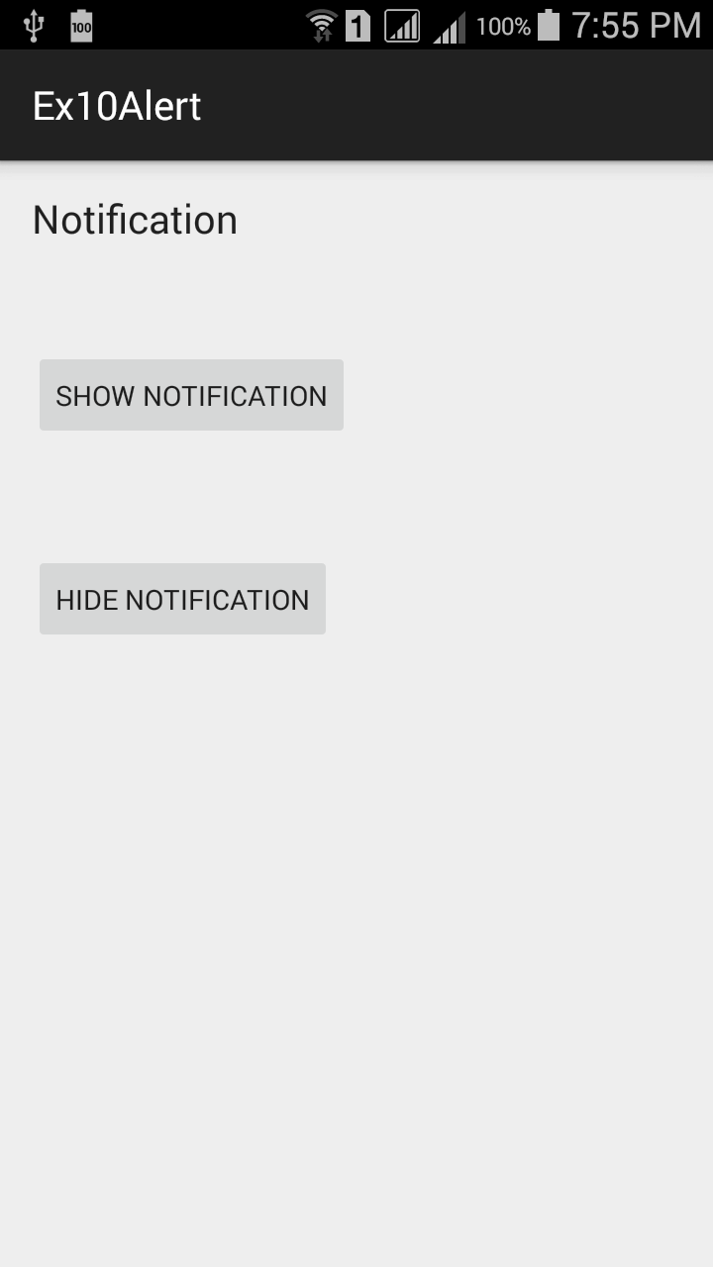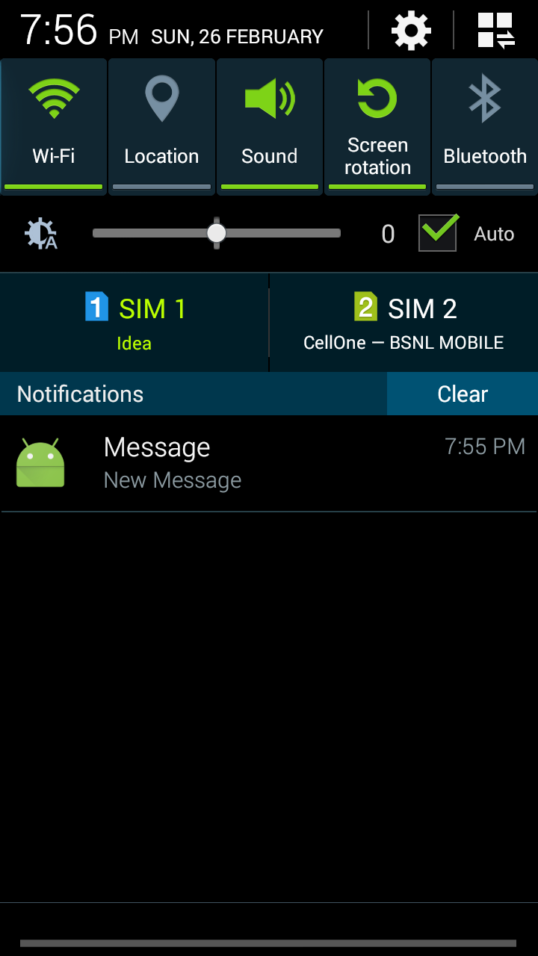

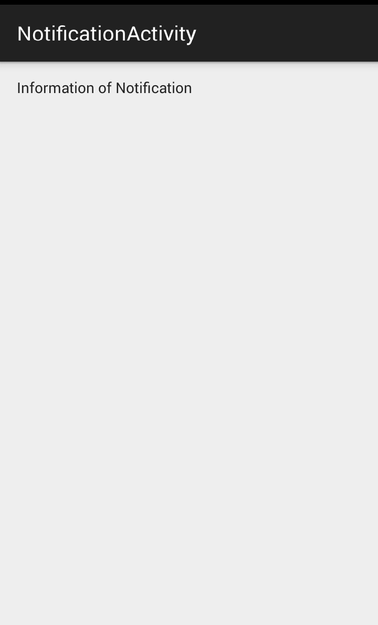

RESULT:
Thus the android application that creates notification alert upon receiving a message using android studio and sdk was developed successfully.

